Sustainable development goals

**12 Responsible production and consumption**

* **Describe what SDG target and goal your indicator is monitoring, and how.**

In this report I’m going to describe two targets for the twelfth goal, responsible production and consumption of the sustainable development goals.

The first target is that they are going to implement a 10-year frame work of programmes with the topic of sustainable consumption and production. The purpose is that the developed counties are taking the lead with the consideration of the development and capabilities of developing countries. This target is indicated by the number of countries with sustainable consumption and production (SCP) national action plans or SCP mainstreamed as a priority or a target into national policies. (SDG 12-1-1, sd)

The second target of goal twelve is that they want to achieve by 2030 sustainable management and efficient use of natural resources. This is indicated or going to be indicated in two ways. First, the material footprint, the material footprint per capita and the material footprint per GDP is going to be measured. The material footprint of consumptions gives information about the amount of primary materials required to serve final demand of a country, so this means basically an indicator for the material standard of living of an economy. (SDG 12-2-1, sd)

The domestic material consumption, the domestic material consumption per capita and the domestic material consumption per GDP is the second thing they will measure. The domestic material consumption of DMS measures the amount of resources that are used in economic processes. DMS is calculated as direct imports of material plus domestic extraction of materials minus direct exports of materials measured in metric tonnes. (SDG 12-2-2, sd)

* **Why is this SDG target and goal important to Aruba?**

The first target: the 10-year framework of programmes on sustainable consumption and production, is important to Aruba in the way that the island strives to produces more with less. Even though the island consists of more than 99 % of goods imported from other countries there is still room for improvement of sustainable production because there is an increase in local businesses who are targeting the sustainable lifestyle in Aruba. (SDG Aruba, sd)

The second target: achieving the sustainable management and efficient use of natural resources by 2030 is vital for Aruba because the limited natural resources Aruba has is an important issue. Aruba is a very small island of 180 square kilometres, which is a small amount of available land as a strategic resource. The planning of the economic development with the efficient use of land is therefore important. The sustainable use of Aruba’s resources will lead to a better quality of life for Aruba’s population and future providing them with the possibility of experiencing and enjoying Aruba’s beautiful environment. Clean sea, air land and preservation of local flora and fauna can be realized if there is investment in the preservation and management of sustainable environment. Therefore, Aruba should reduce its fuel import by 50%, generating mostly its own natural energy resources and reducing the import of food by producing their own organic food by 2025. (Drucker, 2010)

* **How does this SDG target and goal relate to waste management in Aruba?**

Target one: Due to sustainable consumption and production less waste will be produced in Aruba. The Aruban production needs to become cleaner, the goals are to reduce chemical waste and other waste in the air, water and soil. The intention is to raise awareness of the problems throughout the entire food production and consumption and to assist in solutions. (SDG Aruba, sd)

Target two: When managing sustainably and efficiently the available resources, Aruba will have more control over it. Waste management is important in order to protect the natural resources that are available on the island. An example: in Aruba everyone rides a car to remove themselves form one place to another, this chemical waste gets in the air, is absorbed by the sea, plants and all the living beings. Protecting the natural resources in Aruba can be done by replacing the cars to electric vehicles so we have less waste in our air.

* **Find out if the described indicator is being monitored in Aruba:**

Both targets are not monitored in Aruba but the second target: managing sustainably and efficiently by 2030 with indicator 12.2.2 : The domestic consumption, the domestic material consumption per capita, and domestic material consumption have been measured for the US.

In the graphic below you see the US personal consumption expenditure (goods) per captia in millions of US dollars. In the table you see the same data of the measurement in a more structured way. This data was measured by the united states government and is available on the site : https://sdg.data.gov/12-2-2/

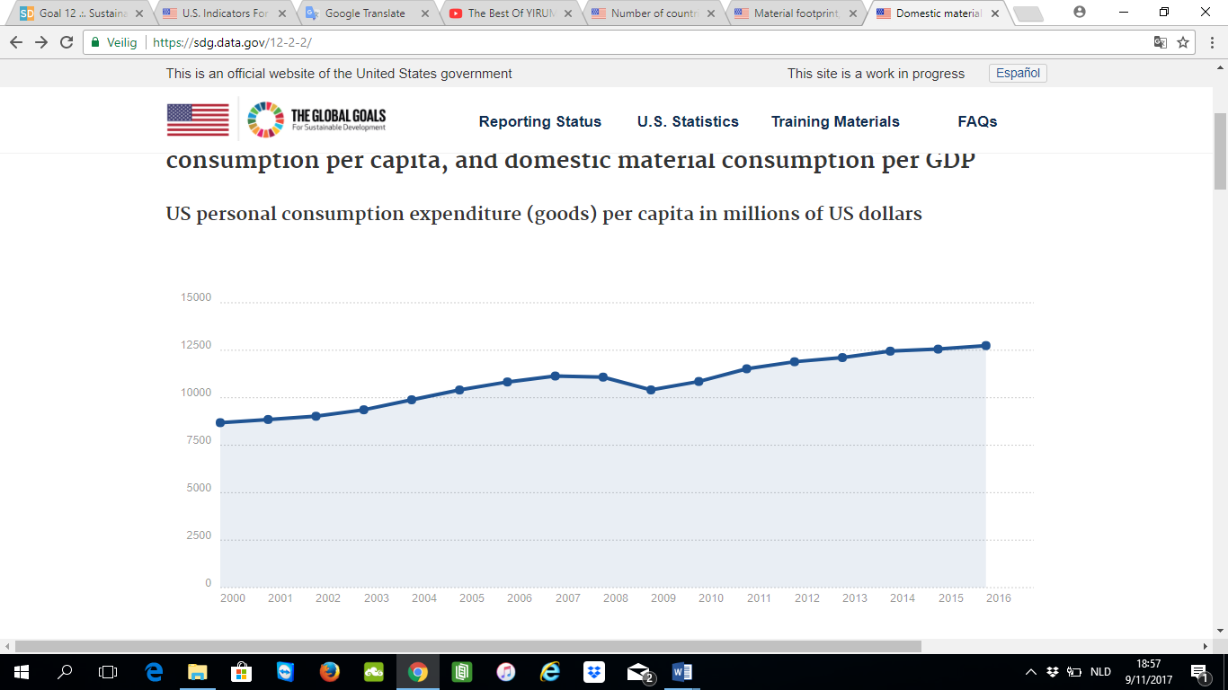

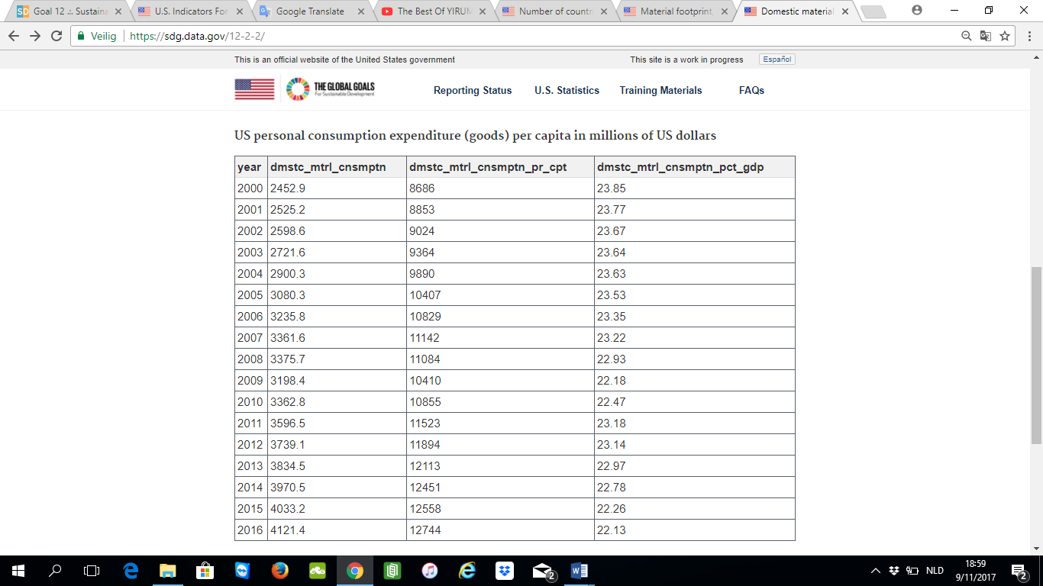

# References

(n.d.). Retrieved from SDG Aruba: http://sdgaruba.com/sdgs/sustainable-consumption-production/

(n.d.). Retrieved from SDG 12-2-2: https://sdg.data.gov/12-2-2/

(n.d.). Retrieved from SDG 12-1-1: https://sdg.data.gov/12-1-1/

(n.d.). Retrieved from SDG 12-2-1: https://sdg.data.gov/12-2-1/

Drucker, P. (2010). *National Integrated Strategic Plan Aruba 2025.*